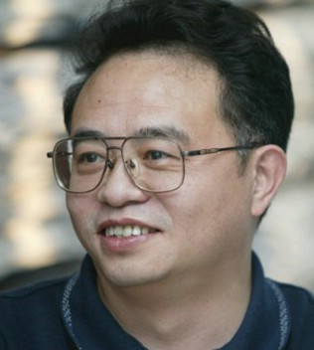
特邀报告1：基于成像几何和结构先验的三维场景建模
报告人: 查红彬 教授 北京大学
摘要：
三维重建是计算机视觉最重要的研究问题之一，在计算机动画、医学图像处理、科学计算、虚拟现实、数字媒体创作等领域具有广泛的应用。经典的运动恢复结构（SFM）仅依靠稀疏特征点来计算场景的相机参数和场景点云模型，获取逼真场景模型的主要困难来自于重建问题自身的二义性、相机观测视角的单一性、图像噪声和光照变化的干扰、前景遮挡和分辨率不足的数据缺失等。如何发现和利用相机成像几何和场景结构先验的信息、编码人类感知系统所启发的几何和结构知识、挖掘重建问题中的附加形状约束，是解决基于图像三维建模的重要研究课题。
在相机成像几何方面，我们探索了基于双平面镜的单目重建方法：不需要多目相机之间的同步和标定，利用射影几何原理，使用单目投影轮廓实现相机标定，通过引入两个额外变量实现对圆环点的像的闭式求解，从一幅图像中的投影轮廓中恢复所有虚拟视点对之间的基本矩阵。利用动态物体的图像序列提高标定精度，并使用相机标定参数和物体轮廓进行重建，能够方便地获得物体三维模型。
在场景结构分析方面，我们探索了基于学习或基于语法的形状自动增强方法：研究了使用场景物体形状先验的建模算法。通过拆分重拼装的方式，类比先验形状数据库中相似物体部件，增强形状的精细几何结构，使用马尔可夫随机场的能量最小化模型进行优化求解，有效提高了深度传感器数据的精度和解析度。还研究了利用立面布局语法的建筑物重建算法，结合自底向上的图像分析和自顶向下的语法解析，完成高精度的建筑物建模。
个人简介：
查红彬，北京大学信息科学技术学院智能科学系教授（教育部长江学者奖励计划特聘教授）。1990年在日本九州大学工学院获博士学位。现任北京大学信息科学技术学院副院长，智能科学系主任，机器感知与智能教育部重点实验室主任。
主要从事计算机视觉、模式识别与智能人机交互的研究，在三维视觉几何计算、三维重建与环境几何建模、三维物体识别、三维人脸动画和动态目标跟踪等方面取得了一系列成果。出版学术期刊及国际会议论文300多篇，其中包括IEEE Trans. PAMI，Int. J. Computer Vision, IEEE Trans. VCG, IEEE Trans. RA, IEEE Trans. SMC,ACM TIST, Pattern Recognition 等国际期刊以及ICCV, ECCV, CVPR, CHI, ICML, AAAI,ICRA等国际学术会议论文60 余篇。

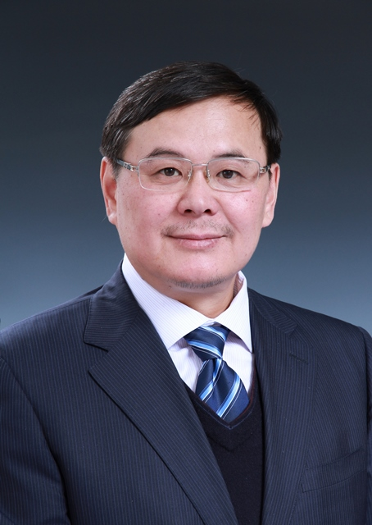
特邀报告2：Scene modeling from transient light transport
报告人：戴琼海 教授 清华大学
Abstract:
Transient Imaging breaks through the long-stand assumption that the speed of light is infinite, and records the optical response of scenes to ultra-short pulsed illumination. By capturing time-resolved light transport information, the transient images provide a brand new perspective for modeling the surface and subsurface of natural scenes. Benefited from the transient information, we can observe the process of light transportation, analyze its interaction with target scenes, and infer their properties, including 3D geometry, reflection attributes, etc.
Firstly, this talk introduces the principles of transient image sampling and compares two types of transient imaging systems: an ultra-fast time-domain setup consisting of a femtosecond laser and a streak camera being able to acquire a trillion frames per second; a frequency-domain sampling system consisting of a multi-frequency time-of-flight (TOF) which implements portable transient imaging of large-scale scenes. Then, we introduce scene modeling via transient light transport, including deriving the geometrical structure from time-resolved light transport, and inferring the reflection attributes of surfaces by decoupling light transport components under the framework of compressive sensing. The researches on transient images provide a new way to observe ultra-fast natural phenomena.
Brief CV:
Qionghai Dai received the Ph.D. degrees in automation from Northeastern University, Shenyang, China, in 1996. From 1997 to 1999, he was a Postdoctoral Researcher in the Department of Automation, Tsinghua University.
Since 1999, he has been with the faculty of Tsinghua University: 1999-2004, as an associate professor; 2005-present, as Professor and the Director of the Broadband Network and Digital Media Laboratory. He now also serves as the associate dean of the Department of Automation. He was awarded the Distinguished Young Scholars of NSF China in 2005.
Prof.Dai’s researches focus on the fundamental challenges and key technologies in computational photography, stereo vision and high-dimensional signal processing, include: built a multi-scale dynamic light field system, unveiled the intrinsic mechanisms under joint multi-view and illumination optimized capture, and raised the temporal resolution up to 2 orders of magnitude; proposed an ultra-fast lens-less computational imaging system based on the emerging femto-photography field. He has published more than 100 papers on peer-reviewed journals and conferences, including 42 papers on IEEE Trans. on SP, PAMI, IP, CSVT, STSP, and IJCV etc, Besides, he holds 58 patents of China.

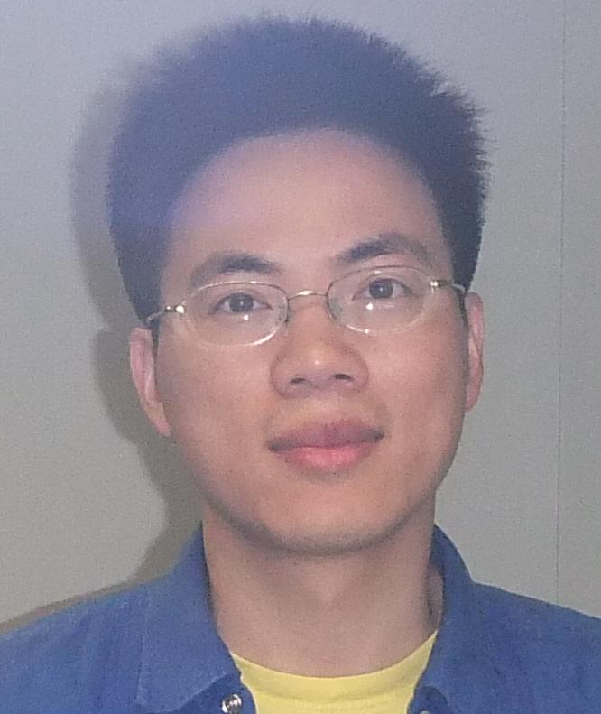
特邀报告3：Stereo Matching Using Tree Filtering
报告人：杨庆雄 助理教授 香港城市大学
Abstract:
Matching cost aggregation is one of the oldest and still popular methods for stereo matching. While effective and efficient, cost aggregation methods typically aggregate the matching cost by summing/averaging over a user-specified, local support region. This is only locally-optimal, and the computational complexity of the full-kernel implementation usually depends on the region size. This talk re-examines the cost aggregation problem using a minimum spanning tree. The matching cost values are aggregated adaptively based on pixel similarity on a tree structure derived from the image to preserve depth edges. The nodes of this tree are all the image pixels, and the edges are all the edges between the nearest neighboring pixels. The similarity between any two pixels is decided by their shortest distance on the tree. This method is non-local as every node receives supports from all other nodes on the tree. It can be further extended for other computer vision and computer graphics applications including image abstraction, edge extraction, detail enhancement, clip-art restoration , inverse halftoning, texture suppression and replacement.
Bio:
Prof. Yang, Qingxiong is an assistant professor at City University of Hong Kong, China. He obtained his PhD degree in Electrical & Computer Engineering from University of Illinois at Urbana-Champaign (UIUC) in 2010 and BEng degree from University of Science & Technology of China (USTC) in 2004. Dr. Yang's research interests reside in computer vision and computer graphics. He won the best student paper award at MMSP 2010 and best demo at CVPR 2007. http://www.cs.cityu.edu.hk/~qiyang/
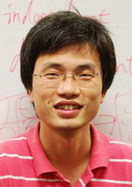
特邀报告4：3D vision for Graphics
报告人：谭平 副教授 新加坡国立大学
Abstract:
3D reconstruction is a fundamental problem in computer vision. This talk presents a structure-from-motion algorithm that solves the 3D reconstruction problem by a single linear equation, instead of following the conventional incremental reconstruction pipeline. Our global algorithm brings more accurate results and achieves significantly improved computational efficiency. We then apply our 3D reconstruction for image-based modelling, motion capture, and image and video editing applications. Our image-based modelling is demonstrated at city-scale scenes, and our motion capture technique requires only a few handheld video cameras, all because of the strength of our structure-from-motion system. We also demonstrate novel image editing application with a simple non-rigid structure-from-motion method.
Bio:
Ping Tan is an associate professor at the Department of Electrical & Computer Engineering at National University of Singapore. He received the Ph.D. degree in Computer Science & Engineering from the Hong Kong University of Science and Technology in 2007. Before that, he received the B.S. degree in Applied Mathematics and M.S. degree in Pattern Recognition and Intelligent System from Shanghai Jiao Tong University, China, in 2000 and 2003 respectively.
Dr. Tan serves as an editorial member of the International Journal of Computer Vision (IJCV), an associate editor of the Machine Vision and Applications (MVA). He has served in the program committees of SIGGRAPH, SIGGRAPH Asia. He received the inaugural MIT TR35@Singapore award in 2012 (among 12 top innovators under 35 from Southeast Asia, India, Australia, and New Zealand), the Image and Vision Computing Outstanding Young Researcher Award Honorable Mention Award in 2012.

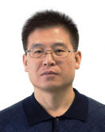
特邀报告5：基于图像的大场景三维重建
报告人：胡占义 研究员 中科院自动化所
摘要：
首先简要介绍一下基于图像的大场景三维重建的一些最新趋势和进展，然后重点介绍基于灰度序的特征描述和匹配方法以及基于成像辅助信息的快速大场景三维重建方法，最后介绍一些基于层次化条件随机场框架下的三维场景分割和理解的相关工作。
简介:
胡占义，1985年毕业于北方工业大学自动化系。1986年12月至1993年2月在比利时列日大学电子工程系读博士。1993年1月获比利时国家博士学位，专业为计算机视觉。1993年至今在中科院自动化所工作，1997年5月至1998年5月在香港中文大学进行合作研究。曾任“十五-863”信息获取和处理主体专家组成员，国家绕月探测科学应用专家委员会委员，国家自然科学基金信息学部第三、第四届咨询专家委员会委员。目前为《计算机辅助设计和图形学学报》副主编，《中国科学》编委，《科学通报》，JCST编委， ICCV’2005 组委会cochair， ACCV’2012 程序委员cochair。2004年获国家自然科学二等奖。主要研究方向有：摄像机标定，三维重建，基于生物视觉机理的建模等。

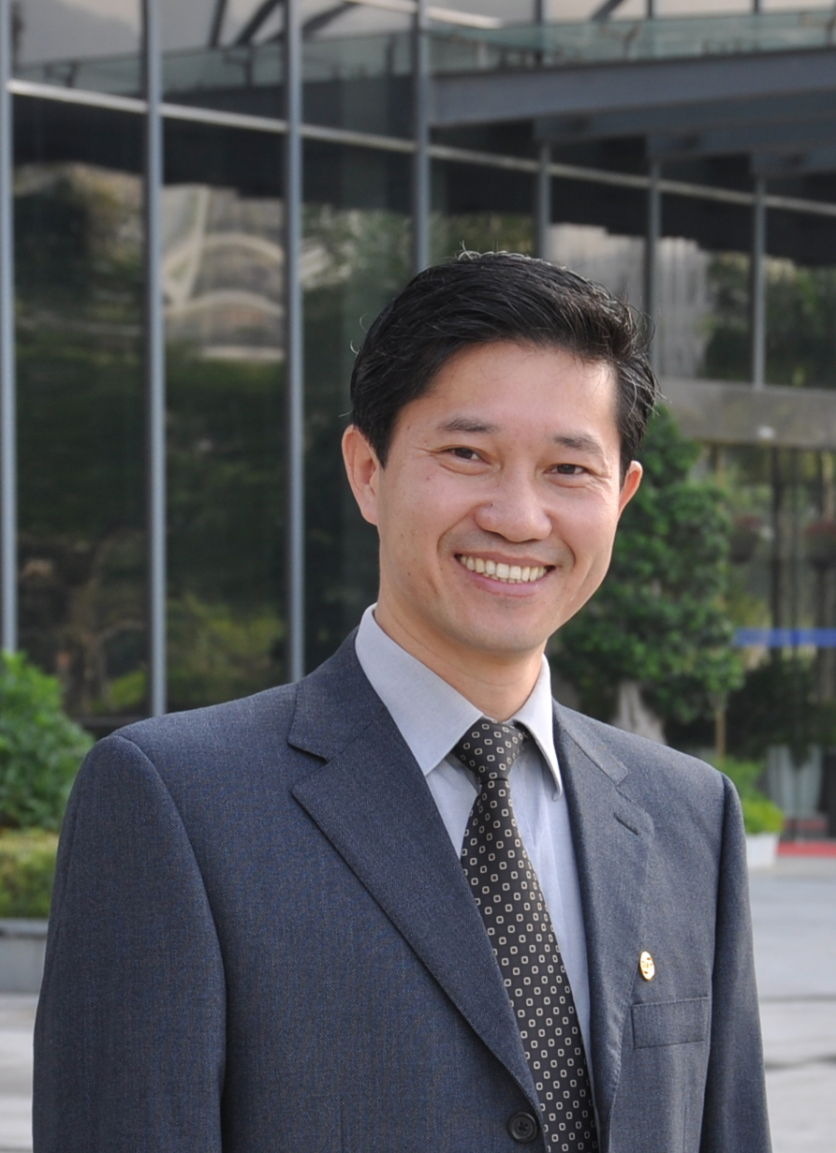
特邀报告6：基于图像与点云融合的三维建模
报告人：陈宝权 教授 山东大学
摘要:
三维建模仍然是计算机图形学与虚拟现实的一大关键研究问题。近年来，三维传感技术获得了长足的发展，从被动式影像传感到主动式激光传感，三维数据获取之多源与多模态为高效精准建模提供了机遇，但也带来了新的挑战。本报告重点介绍基于图像与点云的建模方法，以及如何融合两类数据来实现单一数据所不能达到的建模效果。
简介:
陈宝权，山东大学计算科学与技术学院与软件学院院长、教授，兼中国科学院深圳先进技术研究院研究员，博士生导师。电子工程学士（91年西安电子科技大学），硕士（ 94 年清华大学），计算机博士（ 99 年纽约州立大学石溪分校）。研究方向为大规模城市场景三维获取及海量数据可视化，在 ACM SIGGRAPH 、 IEEE VIS、ACM TOG等国际会议和刊物发表论文 100 余篇。现任IEEE​ Transactions on Visualization and Computer Graphics编委；​​任SIGGRAPH ASIA 2014会议主席、SIGGRAPH​ ASIA指导委员会委员、和IEEE VIS指导委员会委员​；曾任IEEE 可视化会议 2005 年主席和 2004 年程序委员会主席。获 2003 美国 NSF CAREER 奖， 2005 年 IEEE可视化国际会议最佳论文奖； 2008 年入选中科院 " 百人计划 " ； 2010 年获国家杰出青年科学基金资助；2013年人选国家“百千万人才”工程计划和“中青年领军人才”。

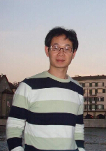
特邀报告7：基于编码结构光的三维视觉方法
报告人：陈胜勇 教授 浙江工业大学
摘要：
编码结构光三维视觉技术，其原理是用一组摄像机和模式投射仪装置形成立体视觉结构，投射出一组经过编码的能量模板并投射到物体表面上，
感知摄像机探测到经物体表面反射的能量后即可利用三角形原理进行三维重构。这种结构化的光模板编码技术有多种。简单地，用一个LCD视频投影机和一个CCD摄像机就可以组成这样的一个系统。本报告针对动态环境或者运动视觉系统的快速三维获取，研究一次性光投射和一次性图像获取及快速的二维到三维的计算，开发一种特殊的结构光编码方法以进行高效编码解码并用于快速三维感知，从而提高物体表面的重构效率。
简介：
陈胜勇，教授，博士生导师，IET Fellow，国家杰出青年基金获得者、德国洪堡基金获得者、浙江省“千人计划”入选者、浙江省151工程第1层次培养入选者、一级学科博士点方向负责人、教育部高校教指委员、英国特许工程师及认证官；香港城市大学博士，英国剑桥大学和帝国理工学院访问教授。发表SCI期刊论文100多篇，出版学术著作10部，3次获IEEE国际最佳论文奖；获授权发明30多项。主持国家基金4项、国家科技计划项目1项。担任多种国际期刊的主编和副主编。

